Reading Vocabulary

📖 What is Reading Vocabulary
# Source: AI Source: Provided by: [Data Path: Persons Table -> ID Column: 1, Name_En Column: Motasem Essam] -> From: [Chatgpt (GPT-4-turbo)] on [7/30/2025]
Reading vocabulary consists of the words you can recognize and understand when reading written text. It is part of your receptive vocabulary and is essential for reading comprehension.

✅ Key Features:
# Source: AI Source: Provided by: [Data Path: Persons Table -> ID Column: 1, Name_En Column: Motasem Essam] -> From: [Chatgpt (GPT-4-turbo)] on [7/30/2025]
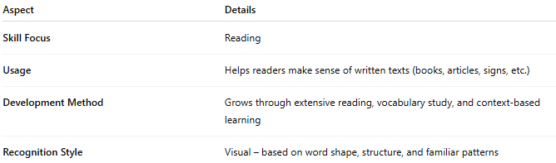
Aspect | Details
Skill Focus | Reading
Usage | Helps readers make sense of written texts (books, articles, signs, etc.)
Development Method | Grows through extensive reading, vocabulary study, and context-based learning
Recognition Style | Visual – based on word shape, structure, and familiar patterns

🧠 Example:
# Source: AI Source: Provided by: [Data Path: Persons Table -> ID Column: 1, Name_En Column: Motasem Essam] -> From: [Chatgpt (GPT-4-turbo)] on [7/30/2025]
- You read the sentence: “The scientist proposed a groundbreaking theory.”
👉 You understand “scientist,” “proposed,” and “theory” as part of your reading vocabulary.

👤 Who Uses It?
# Source: AI Source: Provided by: [Data Path: Persons Table -> ID Column: 1, Name_En Column: Motasem Essam] -> From: [Chatgpt (GPT-4-turbo)] on [7/30/2025]
- All readers, especially:
  - Students building literacy skills
  - Language learners reading in a second language
  - Professionals reading reports, emails, or academic texts

📌 Related Vocabulary Types:
# Source: AI Source: Provided by: [Data Path: Persons Table -> ID Column: 1, Name_En Column: Motasem Essam] -> From: [Chatgpt (GPT-4-turbo)] on [7/30/2025]
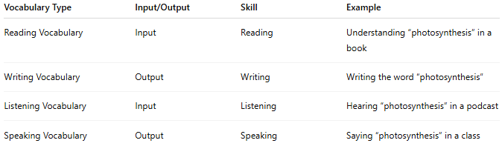
Vocabulary Type | Input/Output | Skill | Example
Reading Vocabulary | Input | Reading | Understanding “photosynthesis” in a book
Writing Vocabulary | Output | Writing | Writing the word “photosynthesis”
Listening Vocabulary | Input | Listening | Hearing “photosynthesis” in a podcast
Speaking Vocabulary | Output | Speaking | Saying “photosynthesis” in a class

